Introduction to Partner Yoga
The following poses are just the tip of the iceberg when it comes to partner yoga. Asana (pose) combinations are limited only by your imagination, so challenge your group to come up with some poses on their own. Remember to warm-up properly before trying more difficult asanas. Most poses can also be practiced on their own, with a partner, and then in a group. Make sure that form is good before progressing to the partner/group pose. Have fun!

Games

Stare Off
- When was the last time you looked into someone else’s eyes for an extended period of time? This is a fun way to introduce the concept
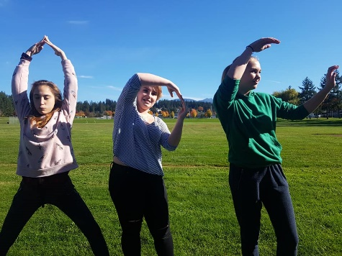

Yoga Letters and Words
- Challenge groups to make letters or words

Intuition Game
- Group sits in a circle
- Discuss intuition/gut feelings
- One person leaves the group, as another person hides an object under themselves/their mat
- The first person returns and uses their intuition to guess who has the object

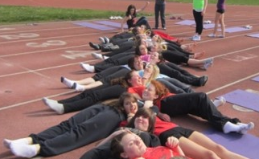
Group Belly Breathing or Laughing
- Everyone lies on the floor with their head on another person’s stomach
- Belly breathing – concentrate on fully inhaling and exhaling through the nose: allow the belly to rise and fall
- Laughing game – last person to laugh wins

Asanas (Poses)

Double Virasana Double Gomukhasana I and II
(Thunderbolt) (Cow’s Face)
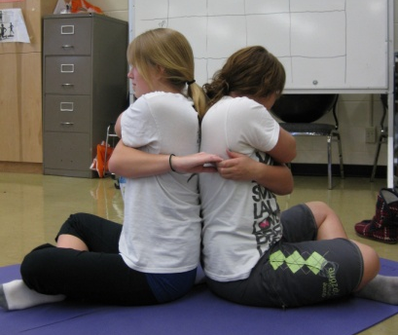
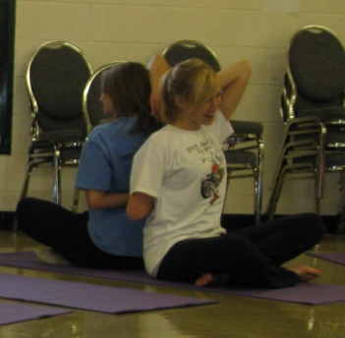
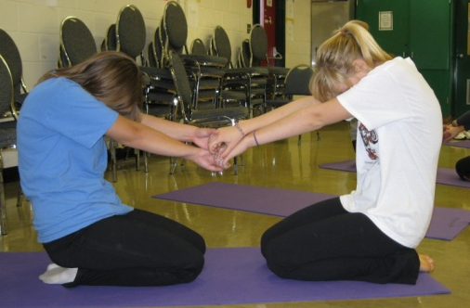
Group Bharmanasana (Tabletop)
Progressions: 1. Warm-up with Cat/Cow 2. Single Person 3. Small Group 4. Large Group
Tip: People who don’t want to participate can help others get in place and then act as spotters
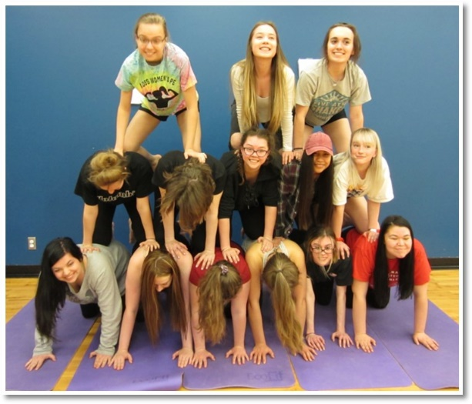
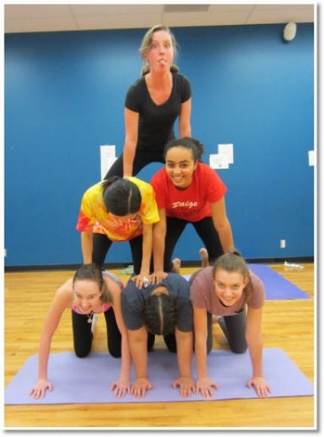

Urdhva Dhanurasana and Ustrasasana Double Rajakapotasana I
(Wheel and Camel) (One-Legged King Pigeon I)
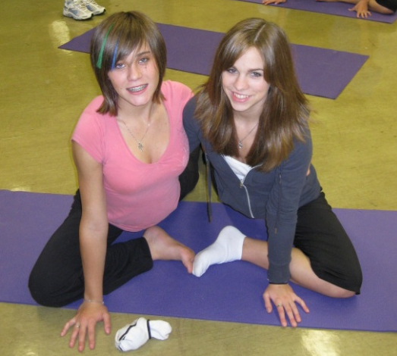
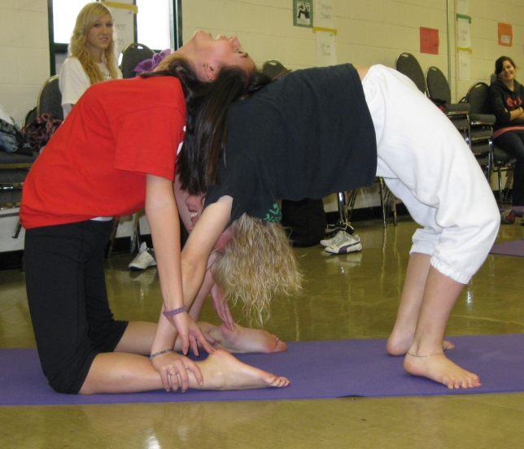

Triple Phalahakasana (Plank) Double Sarvangasana (Shoulderstand)
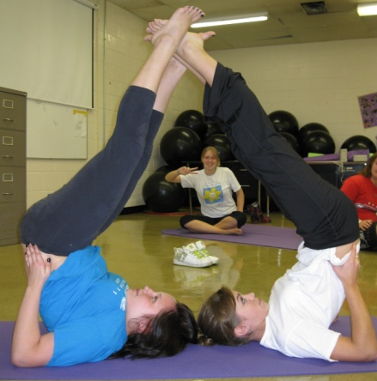
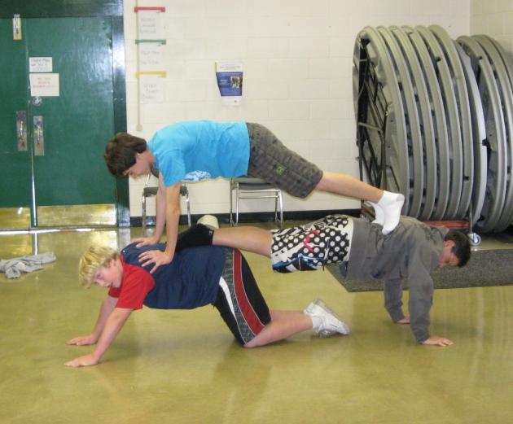

Ardha Adho Mukha Vrksasana and Adho Mukha Svanasana
(Handstand and Downward Dog)
Progressions: 1. Downward Dog with feet at base of wall 2. Supported Handstand (feet on wall) 3. Partner Downward Dog with Handstand 4. One person holding Downward Dog and several people doing a handstand 5. Large group
Tips: No socks, place feet on partner’s low back, in handstand push bum up and emphasize 90° angle with body, when working with a group make sure that you are in position so that others do not have to hold the pose for a long time, have those not participating in group pose help with set up (positioning feet, holding legs, etc.)
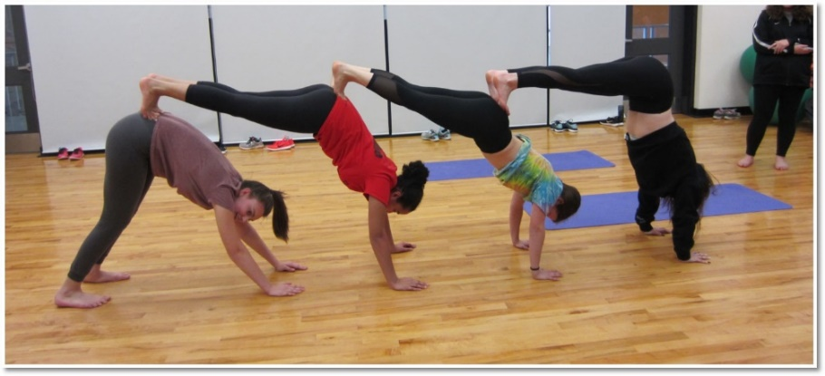
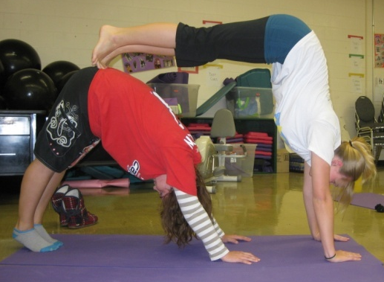

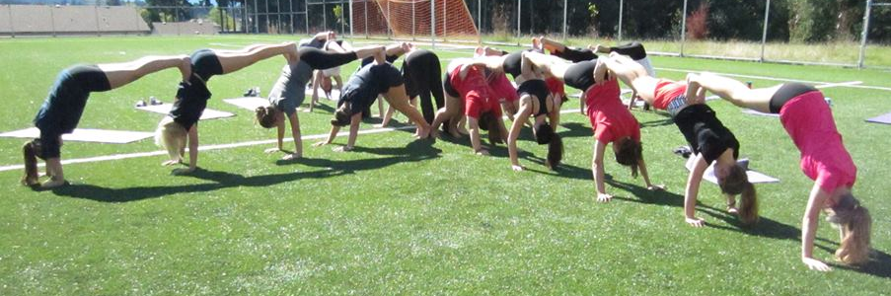
Dandasana and Ardha Adho Mukha Utthita Hasta Padangustasana
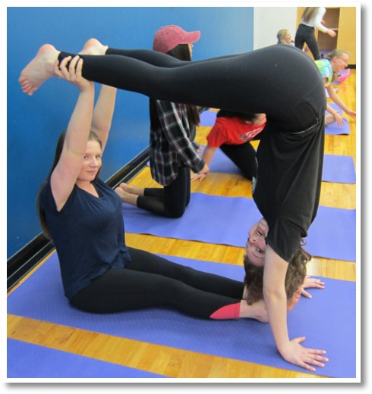
Vrksasana (Staff and Handstand) (Extended Hand to Big Toe)
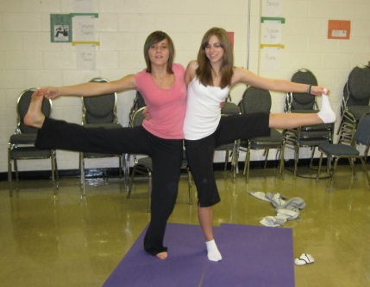

Double Utanasana Double Natarajasana
(Forward Fold) (King Dancer)
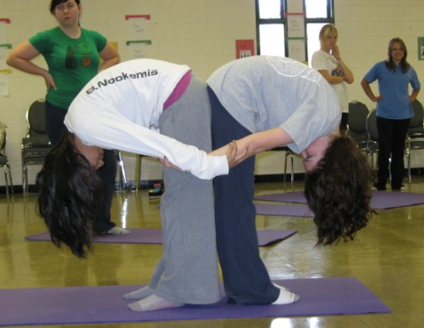
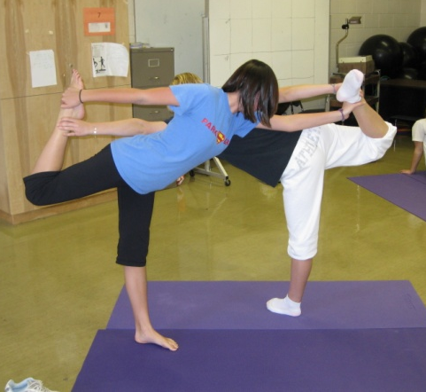

Double and Group Utkatasana (Chair)
Tips for Group Chair: Get tight and make sure that when you sit down both sit bones will be on the lap of the person behind you, sit down and stand up on the count of three
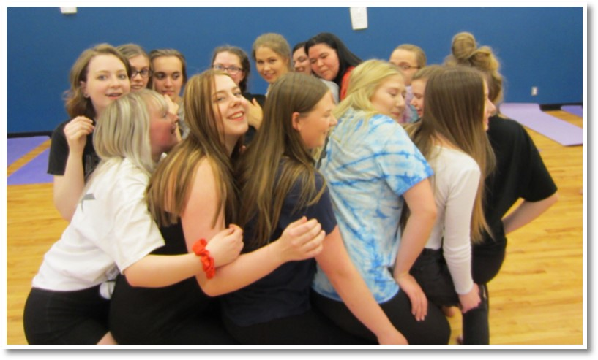
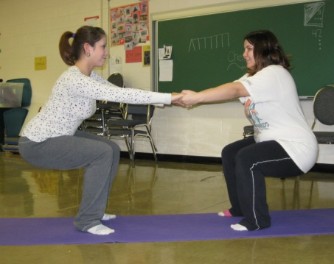
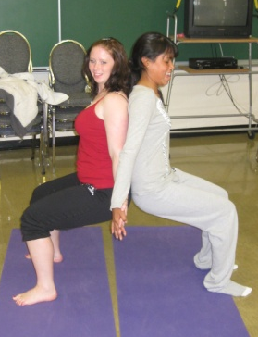

Double Parivrtta Trikonasana (Triangle)
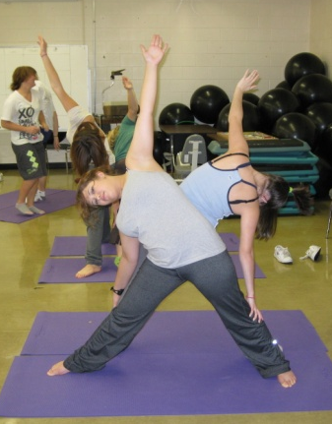
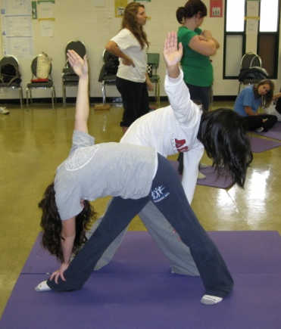
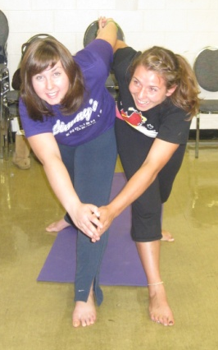

Double Virabhadrasana I Double Virabhadrasana II
(Warrior I) (Warrior II)
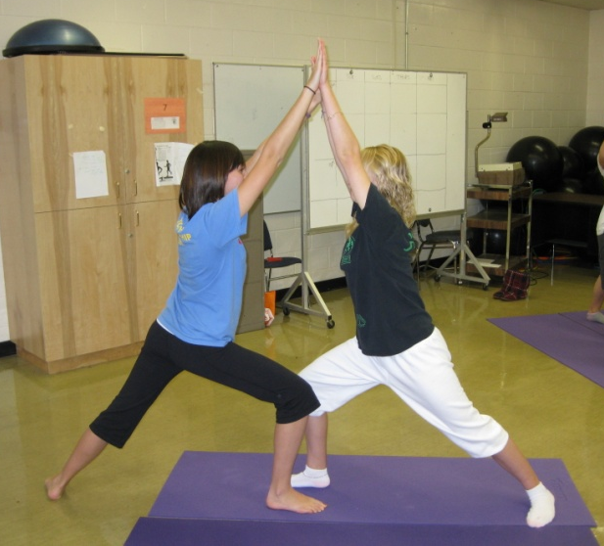
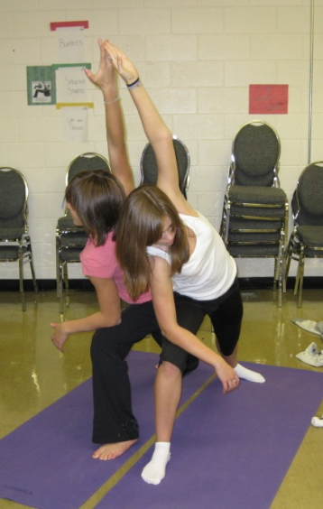

Double and Group Paschimottanasana (Seated Forward Fold)
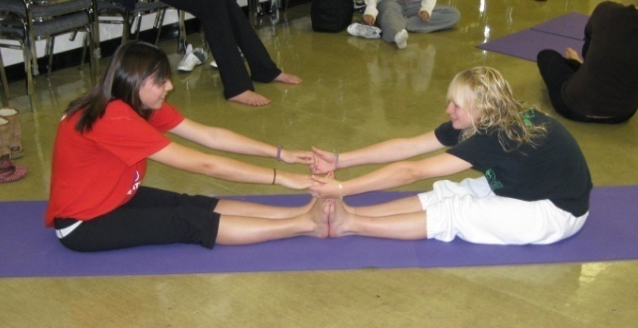
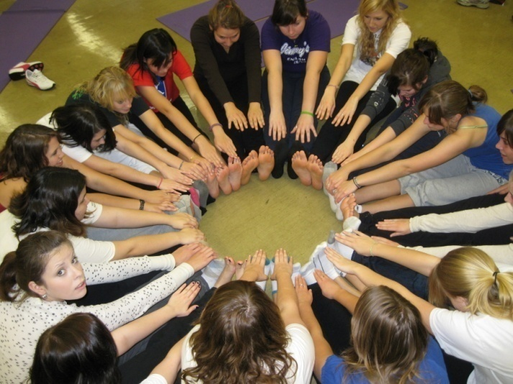

Double and Group Vrksasana (Tree)

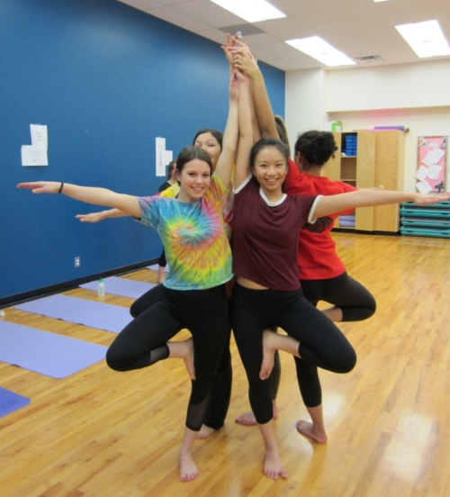
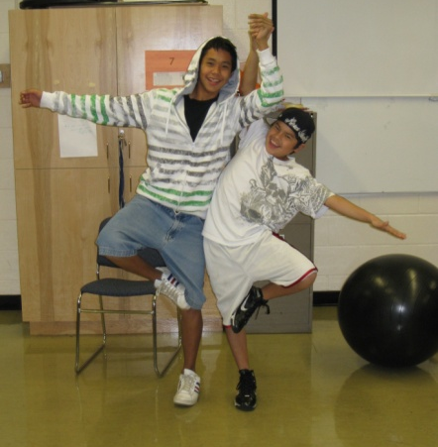
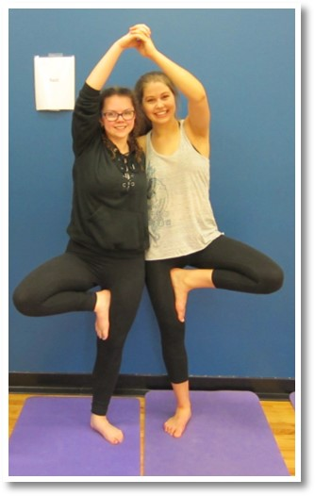

Group activities: Hands together – fingers pointing up and fingers pointing down, arms down by side and up in air, lean right and left, and cross arms across body and clasp hands
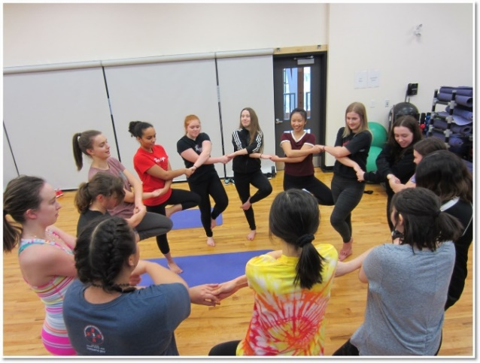
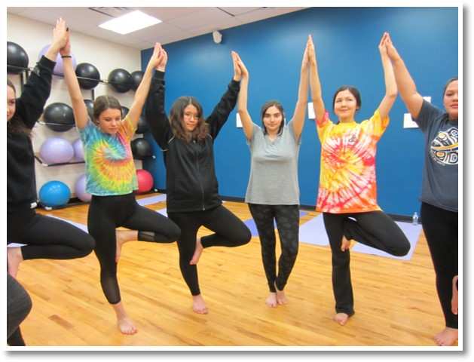

Double Upavistha Konasana Assisted Baddha Konasana
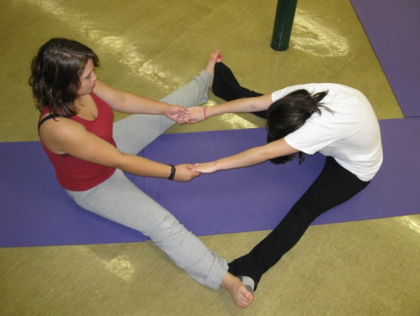
(Seated Wide-Angle Forward Fold) (Seated Bound Angle)

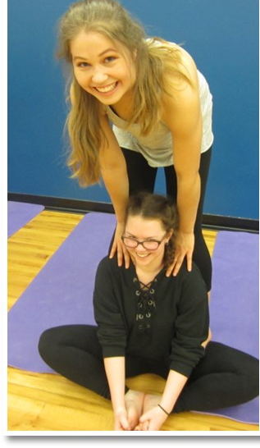

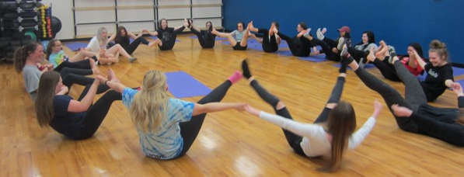
Single, Double and Group Paripurna Navasana (Boat)
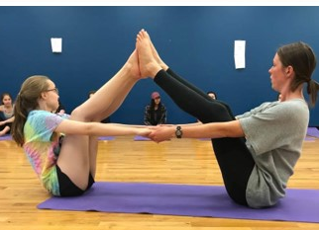

Double Viparita Karani Supported and Uplifted Ardha Dhanurasana
(Legs up the Wall) (Half Bow)
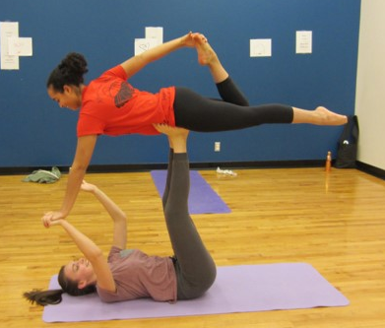
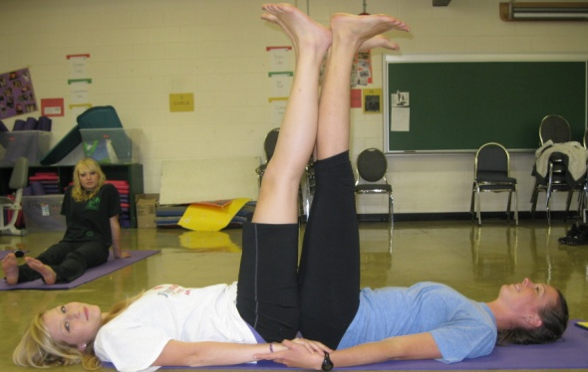

Assisted Balasana Balasana (Child)
(Child) Partner Stretch
