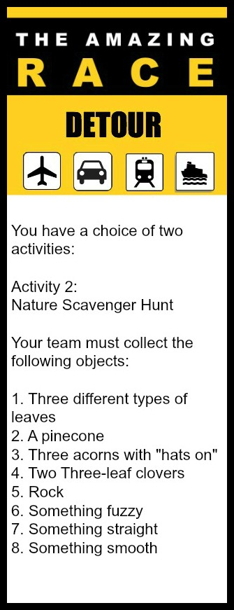
- IN HAND OR ON PHONE: Choose ONE of the following two tasks.
In Hand: Run to the forest behind the Lawn Bowling Club/Echo Centre. Find the following 5 items and bring them back to the outdoor basketball/hockey court – someone will be waiting there to verify your items and give you your next clue.
- A maple leaf
- Moss
- A heart shaped rock
- A pine cone
- A bouquet made of at least three different wildflowers

On phone: Run to the forest behind the Lawn Bowling Club/Echo Centre. Find the following 7 items and take a picture of them. When you have completed the task, run to the outdoor basketball/hockey court – someone will be waiting there to look at your pictures and give you your next clue.
- Your entire group at a disc golf basket
- Your entire group on a bridge
- Someone pretending to be a bear
- Someone “sleeping” on a bench
- A bird
- Someone hiding in the woods
- Something red (that is natural)

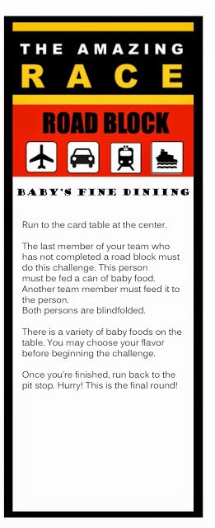
- PUZZLED
Your team must run to Bob Daily Stadium. Do not enter the school! You will find several puzzles scattered throughout the bleachers. Choose one puzzle and complete it as a team. When you have completed the puzzle, take a picture of it and then disassemble it and put it back in the box. Bring the box, along with the picture of the puzzle on your phone back to the outdoor basketball/hockey court for verification, and to receive your next clue.

- BASKETS OR BALLS: Choose ONE of the following two tasks.
Baskets: You will find a basketball in the outdoor basketball/hockey court. Every member of your team must make a basket from the marked spot. You are only allowed to use one of the basketballs, so work as a team to rebound, pass, etc. Once everyone on the team has made a basket from the designated spot, you will receive your next clue.
Balls: You will find a hockey stick and ball in the outdoor hockey/basketball court. Every member of your team must make a shot on the net from the marked spot. You are only allowed to use one of the hockey sticks and balls, so work as a team to fetch balls, pass, etc. Once everyone on the team has made a shot from the designated spot, you will receive your next clue.

- GET THE DIGITS (3)
Visit the following locations to track down the required numbers – it doesn’t matter in which order you visit each location, but your team must stay together. Once you have found all of the numbers and can complete the 4 digit code quietly enter the school and quietly speed walk to the Main Office. When one of the secretaries isn’t busy you will tell them the four digit code. If you are correct you will receive your next clue. If you are incorrect, you will have to visit the locations again and report back to the counselling office with the correct code.

First digit of the code: License Plate: ___06 SHH
Second digit of the code: Echo library back door: No smoking within ___ meters
Third digit of the code: Bob Dailey Stadium: Lane ___, 456.3m, 1497ft
Fourth digit of the code: Large blue dumpster by bike lock-up/tech ed: Phone number 1-877-___27-7833

Code: ___ ___ ___ ___

- GET THE DIGITS (1)
Visit the following locations to track down the required numbers – it doesn’t matter in which order you visit each location, but your team must stay together. Once you have found all of the numbers and can complete the 4 digit code quietly enter the school and quietly speed walk to the Main Office. When one of the secretaries isn’t busy you will tell them the four digit code. If you are correct you will receive your next clue. If you are incorrect, you will have to visit the locations again and report back to the counselling office with the correct code.

First digit of the code: Multiplex: Bulldogs Business Hours __-5pm
Second digit of the code: Bob Dailey Stadium: Outdoor Fitness Equipment: Designed for use by all over the age of 1__
Third digit of the code: Large blue dumpster by bike lock-up/tech ed: Phone number 1-877-__27-7833
Fourth digit of the code: Echo Field House: Plaque: Echo Park officially opened June 24, 19__2

Code __ __ __ __

4. GET THE DIGITS (2)
Visit the following locations to track down the required numbers – it doesn’t matter in which order you visit each location, but your team must stay together. Once you have found all of the numbers and can complete the 4 digit code quietly enter the school and quietly speed walk to the Main Office. When one of the secretaries isn’t busy you will tell them the four digit code. If you are correct you will receive your next clue. If you are incorrect, you will have to visit the locations again and report back to the counselling office with the correct code.

First digit of the code: Multiplex: Bench: In Loving Memory of Jamie Schutte 19__2-2007
Second digit of the code: Bob Dailey Stadium: Lane __, 456.3m, 1497ft
Third digit of the code: Large blue dumpster by bike lock-up/tech ed: Serial G10__78
Fourth digit of the code: Echo Field House: A.V. Softball Assoc. Office E 1__8

Code __ __ __ __

- LIFT THOSE KNEES
Quietly speed walk to the Counselling Office. When one of the secretaries isn’t busy, quietly tell them “We are here to complete an amazing race task”. All team members must then perform the following exercises at the same time in the following order: 10 jumping jacks, 10 squats, and 10 high knees. When all team members have completed the task, your team will receive their next clue.

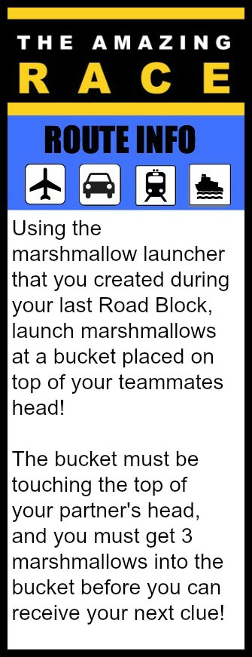
- WHO WANTS TO BE FIRST?
Congratulations! You have completed the ADSS Amazing Race Challenge. Quietly speed walk to the PE Office. The first team to arrive will be the winners!

